JNC

TCP-485

Port Serial to Ethernet Converter or
Modbus Gateway

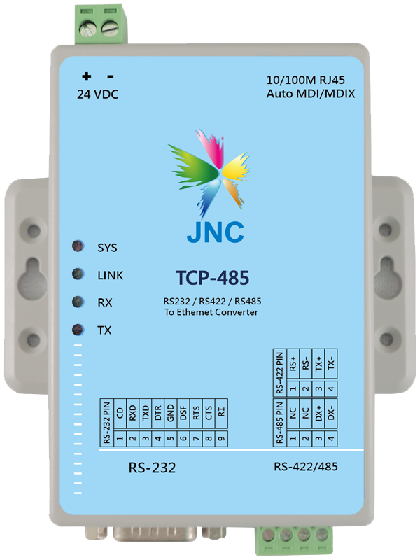
[Features]
- 1 set of RS232/485/422 to Ethernet converter
- Modbus TCP to Modbus RTU converter
- Use HTTP browser or Utility to set
- Built-in password protection function in the setting interface
- Isolated power and low power consumption
- Low cost and high reliability
V JNC TECHNOLOGY CO., LTD. TEL:06-3110008 FAX:06-3110522 E-mail: jnc.jnc@msa.hinet.net
Copyright © 2016 JNC TECHNOLOGY CO., LTD. JNC reserve the right to change the specifications.

[Specifications] [Dimension] ｍｍ
Power Supply | Input Voltage | 24VDC ◆Power consumption:2W
Power Supply | Power Connector | Terminals
Power Supply | Isolation | 2KV
Environment | Working Temp. | 0~60℃ / 5 ~ 95%RH  non-condensing
Environment | Storage Temp. | -40~85℃
Environment | Height | Up to 2000m (795hPa)  peak demand
Ethernet Interface | Communication Method | Modbus TCP
Ethernet Interface | Speed | 10/100Mbps，automatic MDI/MDIX
Ethernet Interface | Transformer isolation protection | 1500VRMS
Ethernet Interface | Quantity of mesh holes | 1
Conversion Interface | Communication Method | Modbus RTU/ASCII Slave/Master
Conversion Interface | ESD protection | All signals are 15 kV
Conversion Interface | RS-485 data transmission | Two-way
Conversion Interface | Quantity of conversion holes | 1
Convert Communication Parameters | Bau rate | 300bps~921.6kbps
Convert Signal | RS-232 | TxD，RxD，RTS，CTS，DTR，DSR，DCD
Convert Signal | RS-422 | Tx+，Tx-，Rx+，Rx-
Convert Signal | RS-485-2w | Data+， Data -
Physical Condition | Product Size (mm) | No hanging ears:25 x 69 x 102  Hanging ears:25 x 94 x 102 (W× H× D)
Physical Condition | Weight | 300g
Shell | Material | PC
Software | Setting method | HTTP Web Console，  Windows Setup Utility
Software | Utilities | Setup Utility for Windows

